|  |  |
| --- | --- |
|  |  |

# Release notes PxWeb 2019 V1

Table of contents

Release notes PxWeb 2019 V1 1

Name changes 5

What is new in PxWeb 2019 V1? 5

Saved queries 5

CNMM 5

Table title in browser tab 5

Menu page 5

Selection page 5

Contact information 5

Chart 6

Sorted table 6

Sort order in selection boxes 6

Improvements in output formats 6

API settings 6

API config endpoint 6

Error page 6

Customized URL:s 6

Rxid removed from URL:s 6

Saved queries 7

Support for CORS and Preflight requests 7

Information about loaded saved query in the UI 8

Open saved query links from MS Office documents 8

Change output format for saved query in URL 9

Redirect saved query to the selection page of PxWeb 9

Optimized pivot operations 10

Display on screen as default selection 10

Bug fix for cached saved query 10

User authentication 10

Request limiter 11

CNMM (Common Nordic Meta Model) 12

Support for CNMM 2.4 12

Improved performance for variables with many values 12

More relevant logging 12

Automatic footnotes for NPM values 12

MetaId for groupings 12

Support for geographical variables in JSON-stat 12

Optimized performance for DATACELLNOTEs 12

Table title in browser tab 13

Menu explanation 14

Selection page 15

New search method 15

Remember selected values and groupings 15

Improved performance 16

Firefox bug fix for sizing selection boxes 16

Fixed bug in search method when variable has many values 16

Contact information 16

Only display relevant information 16

Changed information order under “About table” 17

Email-addresses are clickable 17

Firefox bug fix for Contact and information 17

Display of text for single values in chart title 17

Sorted table 18

Data values are aligned to the right 18

Correct sorting of NPM values 18

Sort order in selection boxes 18

Improvements in output formats 19

HTML5 table 19

CSV 19

Relational table 19

Json 19

JSON-stat 20

JSON-stat2 20

API settings 21

URL root API 21

Default response format 21

API config endpoint 22

Error page 22

Customized URL:s 22

Rxid removed from URL:s 23

## Name changes

The name has been changed from PX-Web to PxWeb. Also the name for the API has been changed to PxWebApi. The reason for the name changes is that by removing the hyphens in the names it will be much easier to find information about the products in search engines such as Google.

## What is new in PxWeb 2019 V1?

The new version contains extended functionality for saved queries, support for CNMM 2.4 as well as a number of new features in the user interface.

This is what is new in PxWeb 2019 V1:

### Saved queries

* Support for CORS and Preflight requests
* Information about loaded saved query in the UI
* Open saved query links from MS Office documents
* Change output format for saved query in URL
* Redirect saved query to the selection page of PxWeb
* Optimized pivot operations
* Display on screen as default selection
* Bug fix for cached saved query
* User authentication
* Request limiter

### CNMM

* Support for CNMM 2.4
* Improved performance for variables with many values
* More relevant logging
* Automatic footnotes for NPM values
* MetaId for groupings
* Support for geological variables in JSON-stat
* Optimized performance for DATACELLNOTEs

### Table title in browser tab

* Possible to display table title in browser tab

### Menu page

* Menu explanation

### Selection page

* New search method
* Remember selected values and groupings
* Improved performance
* Firefox bug fix for sizing selection boxes
* Fixed bug in search method when many values

### Contact information

* Only display relevant information
* Changed information order under About table
* Email-addresses are clickable
* Firefox bug fix for Contact and information

### Chart

* Display of text for single values in chart title

### Sorted table

* Data values are aligned to the right
* Correct sorting of NPM values

### Sort order in selection boxes

* Bug fix for changed sort order of operations, output formats and views when saving in the Administration tool

### Improvements in output formats

* HTML5 table
* CSV
* Relational table
* Json
* JSON-stat
* JSON-stat2

### API settings

* Default response format
* Route prefix, if you are running API on another server

### API config endpoint

* Information about max number of cells that can be downloaded has been added

### Error page

* Generates HTTP 500 Internal Server Error

### Customized <URL:s>

* Possible to design your own <URL:s>

### Rxid removed from <URL:s>

* The rxid parameter is removed from all <URL:s> in PxWeb

## Saved queries

There are a number of improvements regarding saved queries:

### Support for CORS and Preflight requests

A setting in the Administration tool makes it possible to switch on/off support for CORS (Cross-origin resource sharing) and preflight requests for saved queries. This makes it possible to load and embed the result of a saved query by using for example Ajax technology from your PxWeb site into another web site in another domain.

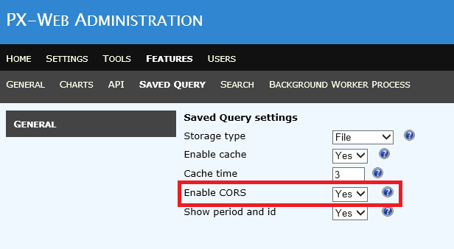

Description of CORS (from Wikipedia):

*“Cross-origin resource sharing (CORS) is a mechanism that allows restricted resources on a web page to be requested from another domain outside the domain from which the first resource was served. A web page may freely embed cross-origin images, stylesheets, scripts, iframes, and videos. Certain "cross-domain" requests, notably Ajax requests, are forbidden by default by the same-origin security policy.*

*CORS defines a way in which a browser and server can interact to determine whether or not it is safe to allow the cross-origin request. It allows for more freedom and functionality than purely same-origin requests, but is more secure than simply allowing all cross-origin requests”*

Description of Preflight request (from Wikipedia):

*“When performing certain types of cross-domain Ajax requests, modern browsers that support CORS will insert an extra "preflight" request to determine whether they have permission to perform the action.”*

See also:  
<https://en.wikipedia.org/wiki/Cross-origin_resource_sharing>

### Information about loaded saved query in the UI

When a saved query has been loaded, information about the saved query is displayed in the UI.

Information displayed is:

* The Id of the saved query
* The time selection for the saved query

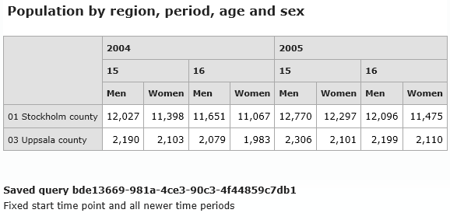

You can switch this functionality on and off in the Administration tool:

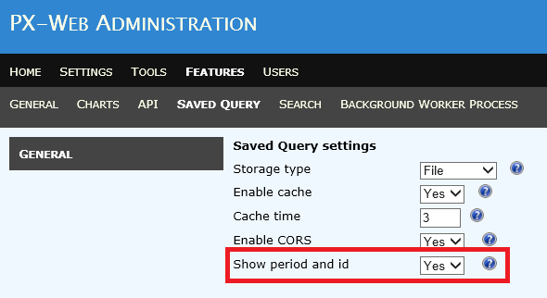

### Open saved query links from MS Office documents

In earlier versions of PxWeb there was a bug that made it impossible to open links to saved queries from MS Office documents. This bug has now been fixed.

### Change output format for saved query in URL

When you save a query you select the desired output format for that query. If you want a saved query for the exact same table but in another output format you earlier had to create a new saved query.

In PxWeb 2019 V1 you can change the output format of an existing saved query by adding a dot (.) followed by the desired output format in the end of the URL.

Example:

URL to the saved query 2555:  
<http://www.mypxweb.com/sq/2555>

URL to the same saved query but with output format Excel:  
<http://www.mypxweb.com/sq/2555.xlsx>

The following output formats are supported by this functionality:

.px - Get result as PX-file  
.xlsx - Get result as Excel-file  
.xlsx_doublecolumn - Get result as Excel-file with double column  
.csv - Get result as default csv-file   
.csv_tab - Get result as tabseparated csv-file without heading  
.csv_tabhead - Get result as tabseparated csv-file with heading  
.csv_comma - Get result as commaseparated csv-file without heading  
.csv_commahead - Get result as commaseparated csv-file with heading  
.csv_space - Get result as spaceseparated csv-file without heading  
.csv_spacehead - Get result as spaceseparated csv-file with heading  
.csv_semicolon - Get result as semicolonseparated csv-file without heading  
.csv_semicolonhead - Get result as semicolonseparated csv-file with heading  
.json_stat - Get result as json-stat-file  
.html5_table – Get result as HTML5 table  
.relational_table – Get result as relational table (txt)

### Redirect saved query to the selection page of PxWeb

The purpose of saved queries has been to get data for a table in a specific output format, on screen or as a file.

If you instead would like to know which variables and values that are selected for a saved query you can add “?select” at the end of the saved query URL. Doing so will instead of displaying the data, redirect you to the selection page of PxWeb with all variables, values, value sets and groupings in the saved query selected in the UI.

Example:

URL for the saved query 2555 that will get you the data in the selected output format:

<http://www.mypxweb.com/sq/2555>

URL for the saved query 2555 that will get you to the selection page in PxWeb:

<http://www.mypxweb.com/sq/2555?select>

### Optimized pivot operations

If multiple pivot operations are made for a saved query they will be replaced by only one “Manual pivot” operation.

### Display on screen as default selection

When saving a query the “Same as shown on screen” option is made the default selection.

### Bug fix for cached saved query

Earlier versions of PxWeb crashed if you loaded a saved query from cache and tried to create a new saved query from that one. This problem is now corrected.

### User authentication

If a database has been set to “protected” (see settings for the database.config file in the PxWeb configuration document) requests for saved queries to that database will be user authenticated. The same authentication component will be used for saved queries as for the rest of the database (that is the component that id configured in the authorizationMethod section of the database.config file).

Example:  
The protection section of the database.config file could look like this:

<protection>  
 <isProtected>True</isProtected>   
 <authorizationMethod>  
 PXWeb.Ssd.Security.SsdProductionAutorization, PXWeb.Ssd  
 </authorizationMethod>  
</protection

### Request limiter

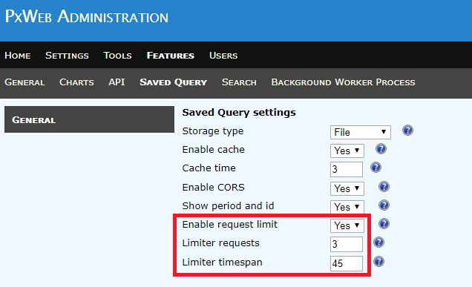

Limit the number of requests to saved queries that can be made from one IP-address for a specified time period (the same functionality that is already implemented for the PxApi).

In the example above only three requests to saved queries can be made during a time span of 45 seconds from a specific ip-address.

## CNMM (Common Nordic Meta Model)

This section is only of interest to you if you are using CNMM, that is running your PxWeb database on for example SQL Server or Oracle. If you are using a PX-file database the following section will not affect your PxWeb web site.

The following improvements have been made regarding CNMM:

### Support for CNMM 2.4

CNMM 2.4 gives you the following possibilities:

* Set default grouping or value set for a variable
* Sort order for groupings and value sets

### Improved performance for variables with many values

The operation of retrieving data from the database has been optimized and has better performance than before, especially if you have variables with many values in your selection.

### More relevant logging

The logging level has been changed. In earlier versions the log-table was filled up with information that in most cases was not of interest. The number of events that are written to the log-table by default has been decreased. However you can still get all logging information if you configure your logging level to DEBUG.

### Automatic footnotes for NPM values

Footnotes are automatically generated if you have NPM values (for example “..”) in your selection.

### MetaId for groupings

MetaId for groupings are handled. This means that it is possible to create links in PxWeb to the definitions of groupings in your metadata systems.

### Support for geographical variables in JSON-stat

See section “Improvements in output formats” below.

### Optimized performance for DATACELLNOTEs

Handling of DATACELLNOTEs have been optimized when using CNMM.

## Table title in browser tab

It is now possible to display the table title in the tab of the web browser:

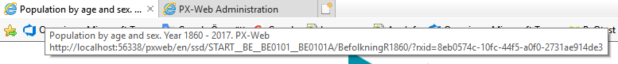

This functionality is controlled by the Settings-> Selection->“Standard application header title” setting in the Administration tool. If set to “True” the text in the browser tab will be displayed as before.

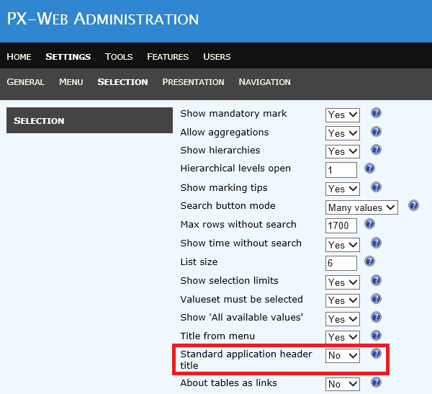

## Menu explanation

On the Menu page an general explanation can be displayed under the selection-tree:

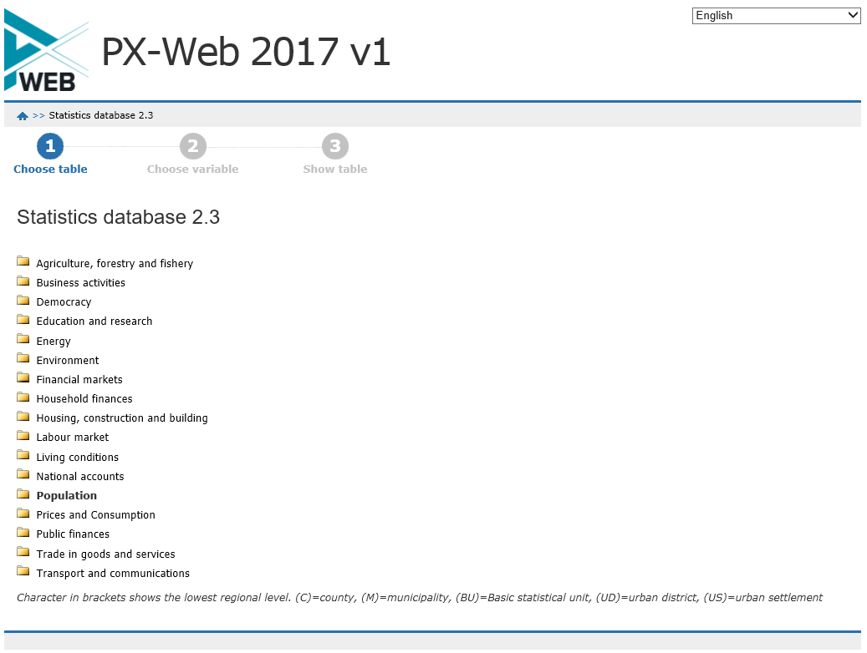

You can switch this functionality on/off via the Settings->Menu->”Show menu explanation” setting in the Administration tool:

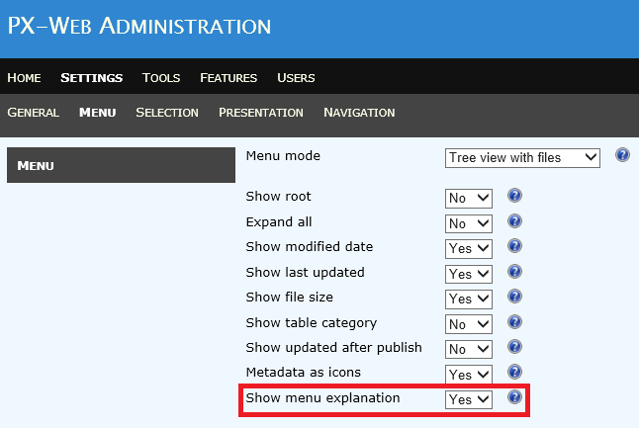

## Selection page

The following improvements have been made to the selection page of PxWeb:

### New search method

The search function “Beginning of row” has been changed to “Beginning of word”:

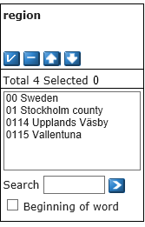

If “Beginning of word” is selected each word in a value is matched against the search criteria.

Via a setting in the Administration tool it is possible to configure if “Free text search” or “Beginning of word” shall be the default search method:

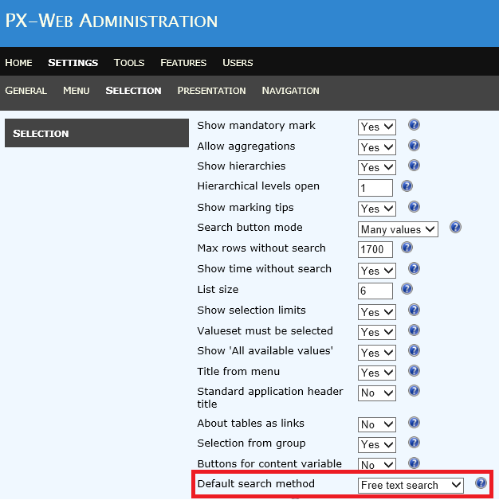

### Remember selected values and groupings

After displaying a table in a presentation view such as a table or chart PxWeb now remember all the selections that were made when you return to the selection page, also value sets and groupings.

### Improved performance

Performance has been improved in the UI, especially if you have variables with many values.

### Firefox bug fix for sizing selection boxes

The selection boxes for the variables now get the same height also in Firefox.

### Fixed bug in search method when variable has many values

In earlier versions of PxWeb the search-function did not work as expected for variables with many values. It is now possible to add more values when doing multiple searches.

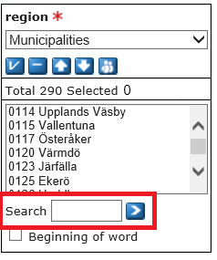

## Contact information

Some changes have been made to the contact information that can be viewed on the selection page and on the presentation views under “About Table”:

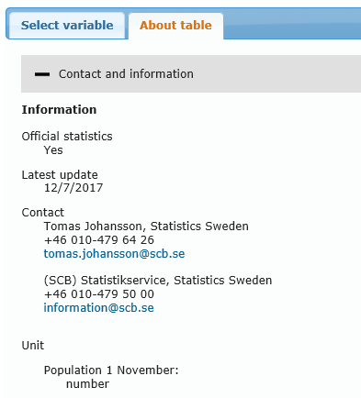

### Only display relevant information

Contact information has been split up. This has made it possible to display only values that have a value. As an example fax number was earlier displayed in the contact information even though no fax number existed.

### Changed information order under “About table”

Information about “Latest update” and contact information have moved up in the list of information.

### Email-addresses are clickable

All email addresses are now clickable and will open up for example Outlook.

### Firefox bug fix for Contact and information

In Firefox it was not possible to expand/collapse the “Contact and information” and “Footnotes” sections. This has been corrected.

## Display of text for single values in chart title

Text for single values are now added to the chart title. This information was missing in earlier versions of PxWeb. The following selection:

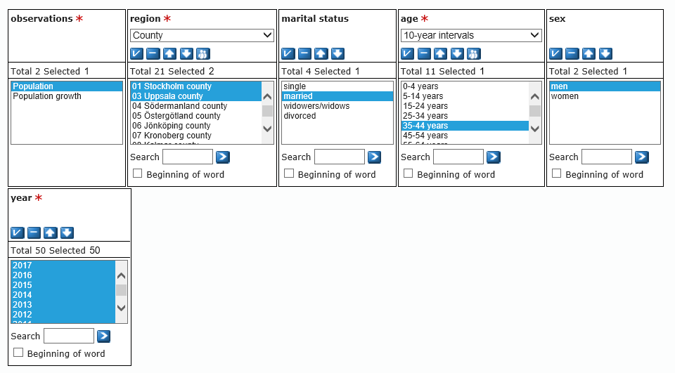

Will result in this chart:

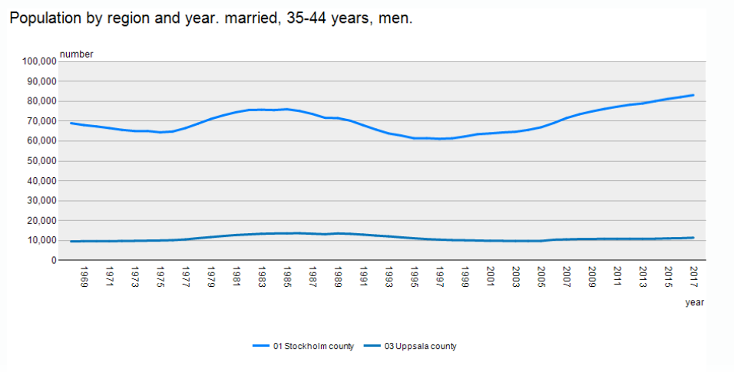

In earlier versions the chart would look like this:

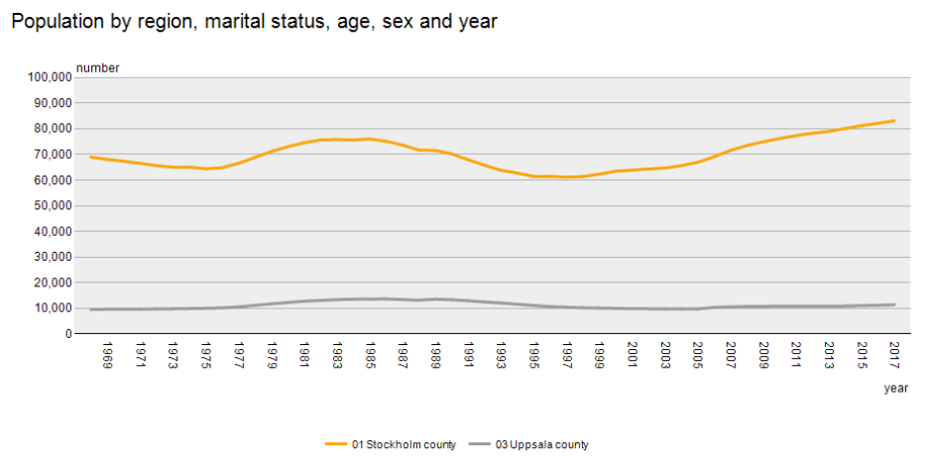

## Sorted table

The following improvements have been made to the sorted table view:

### Data values are aligned to the right

Data values in the sorted table are aligned to the right in PxWeb 2019 v1:

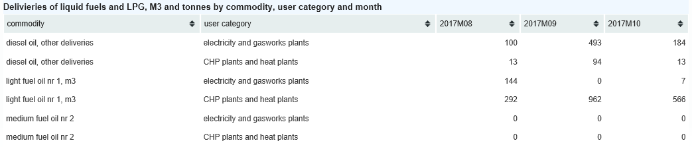

### Correct sorting of NPM values

NPM values are sorted in the same they are defined in the PxWeb Administration tool (Symbol 1, Symbol 2, …, Data Symbol NIL, Data Symbol SUM).

## Sort order in selection boxes

Bug fix for changed sort order of operations, output formats and views when saving in the Administration tool. The sort order of the menu items will now be the same after settings have been saved in the Administration tool.

## Improvements in output formats

A number of improvements have been made to the output formats (file formats).

### HTML5 table

A new output format that will save the statistical table as a HTML5 table. If you want to embed a table in an existing web page this output format will be useful.

Example:  
The following table

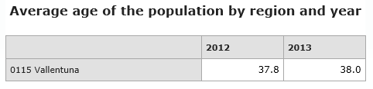  
  
will look like this after it has been saved to HTML5 table output format:  
  
<table id="BE0101G9" >  
<caption>Average age of the population by region and year</caption>  
<thead>  
<tr>  
<th></th>  
<th scope="col">2012</th>  
<th scope="col">2013</th>  
</tr>  
</thead>  
<tbody>  
<tr>  
<th scope="row">0115 Vallentuna</th>  
<td>37.8</td>  
<td>38.0</td>  
</tr>  
</tbody>  
</table>

### CSV

DATANOTECELLs are removed when saving a table to the CSV output format.

### Relational table

The file extension for the relational table output format has been changed from .scb to .txt.

### Json

The Json output format is now available in the API and also in PxWeb.

### JSON-stat

A number of improvements have been made to the JSON-stat output format.

#### Support for geographical variables also for CNMM

It is now possible to get information about which is the geographical variable when using a CNMM datasource.

To get this working you need to configure in web.config the names of the variables that are to be considered as geographical variables. You do this by adding a geoVariables setting in the <appSettings> node of web.config.

In the following example all variables with the name “region” or “area” will be marked as geographical variables when saving to JSON-stat:

<appSettings>  
…  
 <add key=”geoVariables” value=”region,area”/>  
…  
</appSettings>

In the resulting JSON-stat file the following section will be added:

“role”: {  
 “geo”: [“region”,”area”],

#### Decimal rounding

The number of decimals when saving to JSON-stat will be the same as when saving to other file formats as for example Excel.

#### Data notes

If a table contains data notes they will added to the status part of the JSON-stat file:

Example:  
{"dataset":{"status":{"1":"*","2":"*","347":"*"},  
…

### JSON-stat2

PxWeb 2019 v1 has support for the JSON-stat2 output format. This format is only available in the API-part of PxWeb.

To get a table as JSON-stat2 enter *json-stat2* in the response-part of the API-call:

…  
 "response": {  
 "format": "json-stat2"  
 }  
…

## API settings

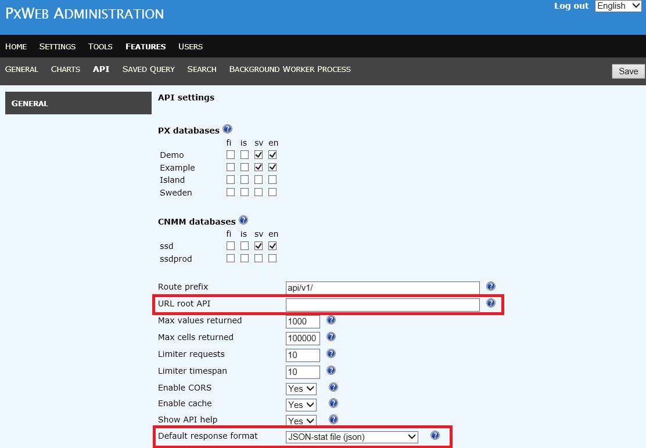

Two new settings are added to the API settings in the Administration tool:

### URL root API

This setting is only useful if you are running the API part of PxWeb on a different server than your PxWeb installation. If this is not the case you should leave this setting empty.

If you for example run the API part of PxWeb on the URL <http://www.mypxapi.com>, you should enter this URL in the **URL root API** setting. This URL will then be displayed in the API-information dialog of how to make API-calls for the selected table.

### Default response format

It is possible to define a default response format for API calls. If the response part of an API call is omitted the data will be returned to the client in the default response format. The default response format will also be the format displayed in the API-information dialog:  
  
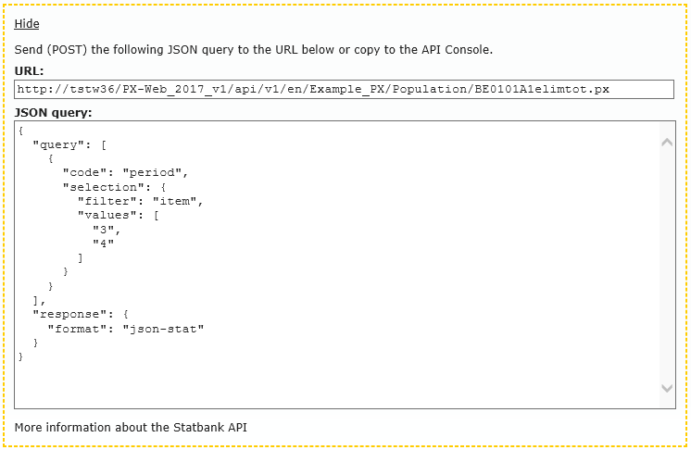

## API config endpoint

In the PxApi there is the config endpoint where you can get information about the settings of the API. You get to the config endpoint in the following way:

http://www.yourpxweb.com/api/v1/en/?config

Information about the maximum number of cells that can be downloaded via an API (POST) call has been added to this endpoint.

You will get the following information in the endpoint:

{  
 "maxValues": 1000,  
 "maxCells": 100000,  
 "maxCalls": 3,  
 "timeWindow": 60,  
 "CORS": true  
}

… if you have these API settings in the administration tool:

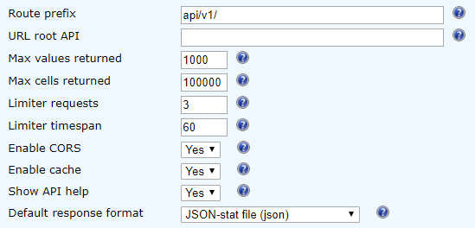

## Error page

If an error occurs in PxWeb the user is redirected to the PxWeb error page. The error page now generates a *HTTP 500 Internal Server Error*, which was not done in earlier versions of PxWeb.

## Customized URL:s

In PxWeb 2019 v1 it is possible to customize the <URL:s> used in PxWeb. This however requires that you implement some code of your own to handle this. For more information about this, contact the developers at Statistics Sweden or Statistics Norway.

## Rxid removed from URL:s

The rxid parameter has been removed from all URL:s in PxWeb.

Example:   
In earlier versions a URL in PxWeb could look like this:

<http://www.mysite.com/pxweb/en/mydb/?rxid=78964b53-54d7-4009-bd0d-49bac8b1f4d3>

For the same URL in PxWeb 2019 v1 the rxid parameter has been removed and the URL will now look like this:

<http://www.mysite.com/pxweb/en/mydb/>

This however comes with some limitations if the user has deactivated javascripts in the web browser.

**If javascripts are activated in the users web browser:**PxWeb will work as before. The user can work with multiple tables in multiple tabs in the web browser simultaneously.

**If javascripts are deactivated in the users web browser:**PxWeb will get problems if the user works with more than one table at a time in different tabs in the web browser. PxWeb cannot decide which table belongs to which tab and the tables will be mixed up. If however the user opens up different instances of the web browser and works with one table in each browser instance, everything will work as expected.